HR ANALYTICS DASHBOARD

1. PROJECT OVERVIEW
This project analyzes Human Resource (HR) data using Power BI, SQL, Python, and Excel. The dashboard helps organizations monitor workforce metrics, employee demographics, salary distribution, recruitment effectiveness, employee performance, and satisfaction levels. It enables HR teams to make data-driven decisions for workforce planning and organizational growth.

2. TOOLS USED
Excel | Data Cleaning & Preparation
SQL Server | Data Querying & Analysis
Python | Data Analysis & Visualization
Power BI | Interactive Dashboard Creation

3. KEY KPIs
• Total Headcount: 45
• Active Employees: 29
• Terminated Employees: 16
• Male Employees: 22
• Female Employees: 23
• Total Salary Expense: 3.1M

4. DASHBOARD INSIGHTS
• Production department has the highest employee count.
• LinkedIn is the most effective recruitment source.
• Majority of employees fall under the “Fully Meets” performance category.
• Most employees report Acceptable to High satisfaction levels.
• Production department contributes the highest salary expenditure.
• Workforce distribution is concentrated across selected states.

5. SAMPLE SQL QUERIES

Total Headcount
SELECT COUNT(*) AS Headcount
FROM HRData;

Active Employees
SELECT COUNT(*) AS Active_Employees
FROM HRData
WHERE EmploymentStatus = 'Active';

Terminated Employees
SELECT COUNT(*) AS Terminated_Employees
FROM HRData
WHERE EmploymentStatus = 'Terminated';

Gender Distribution
SELECT Gender,
COUNT(*) AS Employee_Count
FROM HRData
GROUP BY Gender;

Department-wise Employee Count
SELECT Department,
COUNT(*) AS Employee_Count
FROM HRData
GROUP BY Department
ORDER BY Employee_Count DESC;

Department-wise Salary
SELECT Department,
SUM(Salary) AS Total_Salary
FROM HRData
GROUP BY Department
ORDER BY Total_Salary DESC;

Recruitment Source Analysis
SELECT RecruitmentSource,
COUNT(*) AS Total_Hires
FROM HRData
GROUP BY RecruitmentSource
ORDER BY Total_Hires DESC;

Employee Performance Analysis
SELECT PerformanceRating,
COUNT(*) AS Employees
FROM HRData
GROUP BY PerformanceRating;

Employee Satisfaction Analysis
SELECT SatisfactionLevel,
COUNT(*) AS Employees
FROM HRData
GROUP BY SatisfactionLevel;

6. SAMPLE PYTHON ANALYSIS

Import Libraries
import pandas as pd
import numpy as np
import matplotlib.pyplot as plt

Load Dataset
HR_df = pd.read_csv("HRData.csv")
HR_df.head()

Total Headcount
Headcount = HR_df['EmployeeID'].count()
print("Total Headcount:", Headcount)

Total Salary
Total_Salary = HR_df['Salary'].sum()
print("Total Salary:", Total_Salary)

Employee Count by Department
Dept_Count = HR_df.groupby('Department')['EmployeeID'].count()
Dept_Count.plot(kind='bar')
plt.title("Employee Count by Department")
plt.xlabel("Department")
plt.ylabel("Employees")
plt.show()

Gender Distribution
HR_df['Gender'].value_counts().plot(
kind='pie',
autopct='%1.1f%%'
)
plt.title("Gender Distribution")
plt.show()

Recruitment Source Analysis
Recruitment = HR_df['RecruitmentSource'].value_counts()
Recruitment.plot(kind='barh')
plt.title("Recruitment Source Analysis")
plt.xlabel("Hires")
plt.show()

Salary Distribution
HR_df['Salary'].plot(kind='hist', bins=20)
plt.title("Salary Distribution")
plt.xlabel("Salary")
plt.show(

7. DASHBOARD OVERVIEW

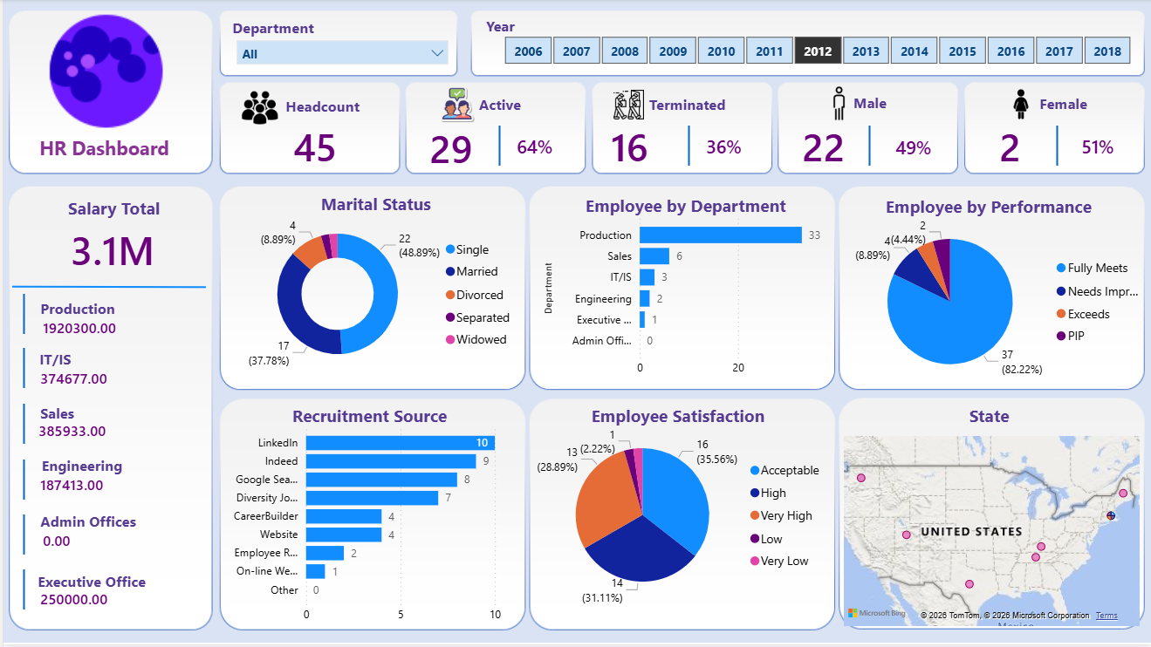

8. CONCLUSION
This project successfully transformed raw HR data into actionable business insights using SQL, Python, and Power BI. The dashboard provides a comprehensive view of workforce demographics, salary expenses, employee performance, recruitment effectiveness, and satisfaction levels. It demonstrates how HR analytics can support strategic decision-making, workforce planning, and organizational growth through data-driven insights.

